SafeHouse Explorer v3.01

*User’s Guide*

[SafeHouseSoftware.com](http://www.safehousesoftware.com/Default.aspx)



**ABOUT THIS DOCUMENT**

This user guide covers all the information required to install and use the SafeHouse Explorer products on several Windows operating systems.

**TABLE OF CONTENT**

1 Introduction 1

1.1 System requirements 1

1.2 Downloading SafeHouse Explorer v3.01 1

1.3 Installing SafeHouse Explorer v3.01 2

2 Getting Started 5

2.1 Launching SafeHouse Explorer 5

2.2 Performing basic tasks 6

2.2.1 Creating volumes 6

2.2.2 Opening and closing volumes 8

2.2.3 Adding private files to SafeHouse Explorer 9

2.2.4 Moving file to another folder 10

2.2.5 Creating new folder in SafeHouse volume 10

2.2.6 Deleting files 11

3 Working with protected files in SafeHouse Explorer 13

3.1 Tools and Options 13

3.1.1 Changing a SafeHouse password 13

3.1.2 Making Self-extracting volume 14

3.1.3 Extracting volume from .exe 14

3.1.4 Copying files to memory sticks 14

4 Using Smartcard with SafeHouse 21

5 Uninstalling 25

6 Frequently asked questions 27

7 Troubleshooting 29

8 Glossary 31

9 Index 33

# Introduction

SafeHouse Explorer version 3.01 is free encryption software that helps to protect confidential files. The free version of SafeHouse Explorer is fully featured with a lifetime license. This software protects private documents and important files by locking and keeping them safe from unauthorized data access. This encrypted data can be viewed only after entering a password.

To hide and protect important files, including photos, videos, databases, and many more, SafeHouse Explorer uses 256-bit advanced encryption. SafeHouse Explorer creates private storage of your local drive or external media to hide, lock, and secure private files. It also can be used to protect smartcards. Meanwhile, it can also convert USB drives into the smartcard.

## System requirements

The system requirements for installing SafeHouse Explorer (version 3.01) are as follows:

OS: Microsoft® Windows®2000/XP/2003/2008/Vista/Win7, Win8, Win10

* CPU: Intel® Celeron or higher processor
* GPU: Intel® graphics 172
* HDD: 10 MB of available hard disk space and additional space for your private files
* RAM: 1 GB for Windows® XP SP3, Vista, Win7, Win8, Win10
* Network connection: 512 Kbps for quick download and upgrade
* Browser: Internet Explorer 5.0 or greater

## Downloading SafeHouse Explorer v3.01

To download the accessible version of SafeHouse Explorer, do the following:

1. Click the following link: <http://www.safehousesoftware.com/SafeHouseExplorer.aspx>

SafeHouse Explorer v3.01 download screen is displayed.

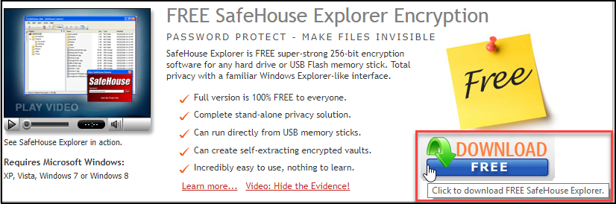

*Figure 1: SafeHouse Explorer v3.01 download screen*

1. Click **Download free.** The .**exe** file will be downloaded to the folder where your system keeps all downloaded files.

## Installing SafeHouse Explorer v3.01

To install SafeHouse Explorer v3.01, do the following:

1. Run the **SafeHouseExplorer-3.01.000-setup.exe** file with the Administrator Rights.

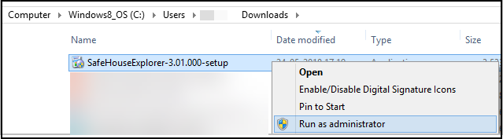

*Figure 2: SafeHouse Explorer setup file*

1. Read the information about the software and click **Next.**
2. Read License Agreement carefully, select I accept this Agreement, and then click **Next.**

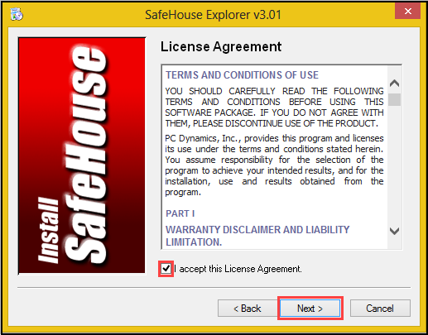

*Figure 3: Accepting License Agreement*

1. Specify the hard drive directory into which to install this software. To create shortcut icon on the desktop, select the check box.

1. Click **Next** to continue the installation process.

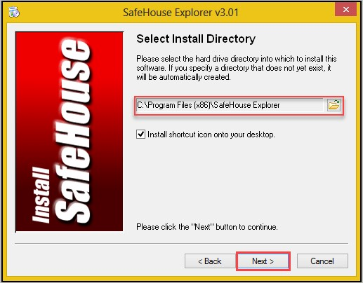

*Figure 4: Selecting install directory*

1. Click **Finish** to exit setup and launch SafeHouse Explorer v3.01.

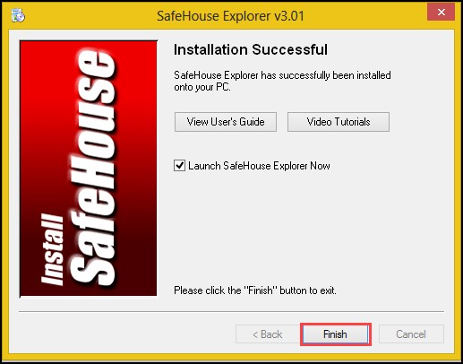

*Figure 5: Installation successful window*

# 2. Getting Started

SafeHouse Explorer v3.01 is a simple product. Spend 10 to 15 minutes with this getting started chapter, and you will get acquainted with all the basic features of this software.

## Launching SafeHouse Explorer

You can search for a SafeHouse Explorer application in the Windows starts menu. Click on the icon to see SafeHouse’s interface.

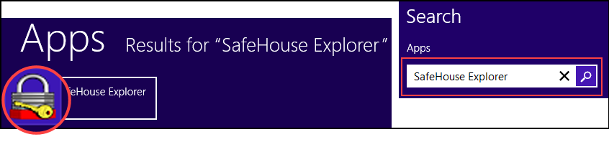

*Figure 6: Opening SafeHouse Explorer*

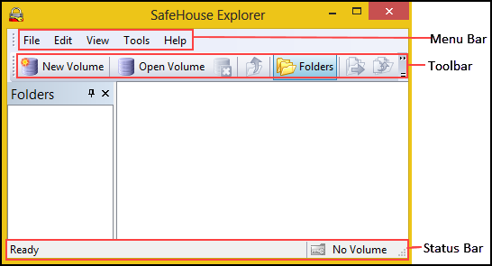

*Figure 7: SafeHouse Explorer v3.01 user interface*

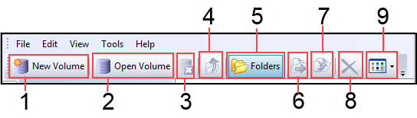

*Figure 8: SafeHouse Explorer Toolbar*

Some features of SafeHouse Explorer Toolbar are as follows:

*Table 1: Description of SafeHouse Explorer v3.01 Toolbar*

|  |  |  |
| --- | --- | --- |
| **Reference Number** | **Name of Field** | **Description** |
| 1 | New Volume | Launches a dialogue to create SafeHouse volume. |
| 2 | Open Volume | Opens a SafeHouse volume. |
| 3 | Close Volume | Closes the SafeHouse volume. |
| 4 | Up (folder) | Navigates up to the parent folder. |
| 5 | Folders | Toggles the Folders pane on and off. |
| 6 | Move to Folder | Moves the selected items to another location. |
| 7 | Copy to Folder | Copies the selected items to another location. |
| 8 | Delete | Deletes the selected items. |
| 9 | Views | Toggles the view attributes for the displayed items. |

## Performing basic tasks

### Creating volumes

The **New Volume** wizard in Safehouse is used to create the container files in which you can store your private files. The volume can be located in internal and external hard drives, network servers, USB flash disks, and memory sticks.

To create **New Volume**, do the following:

1. Start SafeHouse Explorer.
2. Click the **New Volume** (A) button on toolbar **or** click **Tools** tab **>** Click **Create New SafeHouse Volume** (B).

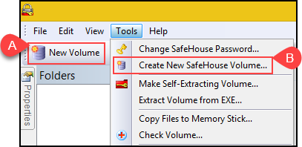

*Figure 9: Creating New Volume*

1. When Create New Volume window opens, click the **Next** button.
2. Specify **folder location** for file storage, **file name**, and **description**. Click **Next** to continue.
3. Specify the volume size of your private storage area and click **Next**.
4. Choose a strong password with an alpha-numeric combination to protect your files and click **Next.**

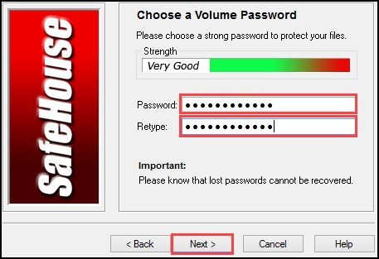

*Figure 10: Creating Password*

1. Click on **Create Volume** and wait for less than one minute.
2. After the volume is created successfully, click Finish to open the newly created volume.

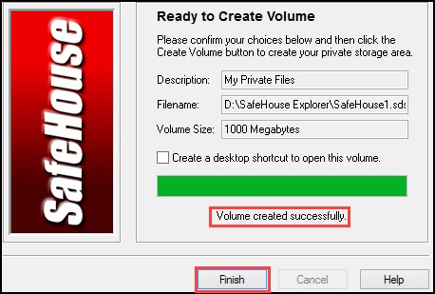

*Figure 11: Volume Created Successfully*

### Opening and closing volumes

To **Open Volume >** Click the **File** tab, select Open Volume from the drop-down, or click the Open Volume button on the toolbar. In the Windows file picker, select the folder location where you created the Volume file (SDSK file type) and click open.

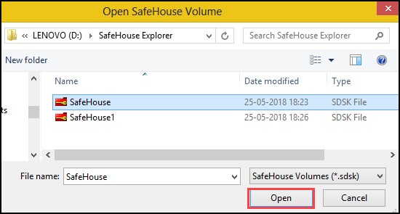

*Figure 12: Opening SafeHouse Volume*

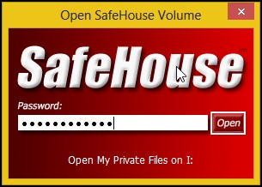

*Figure 13: SafeHouse Password Window*

To **Close Volume** **→** Click **File** tab and select Close Volume from drop-down or click the Close Volume button on toolbar.

### Adding private files to SafeHouse Explorer

You can add private files to the SafeHouse volume just by dragging and dropping the files in SafeHouse Explorer.

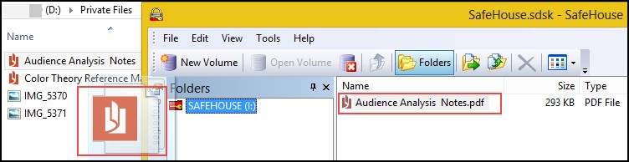

*Figure 14: Adding Files to SafeHouse Volume*

### Moving file to another folder

To move the file to another location, do the following:

1. Select the file and click Move to Folder toolbar button.
2. Select the **Window Folders** checkbox and select the place where you want to move the file and click **Move**.

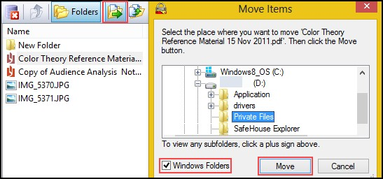

*Figure 15: Moving File to Another Location*

You can follow the same process to copy files to another location.

### Creating new folder in SafeHouse volume

To create new folder in SafeHouse volume, do the following:

Click the **File** tab **→** Select the **New Folder** command from the drop-down.

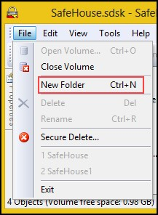

*Figure 16: Creating New Folder*

### Deleting files

SafeHouse Explorer v3.01 provides two types of deletion features, Secure Delete and Normal Delete. When you usually delete the files, they can be recovered. The Secure Delete feature can delete files entirely from your hard drive.

To **Secure Delete** **→** Click the **File** tab **→** Select **Secure Delete** from the file menu **→** Select any number of files and folders **→** Click the **Select** button to proceed **→** Click **Yes** to delete files and folders.

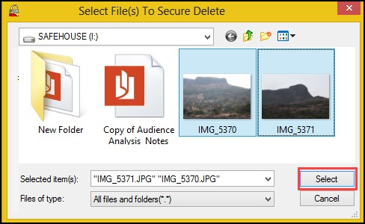

*Figure 17: Selecting Files to Secure Delete*

# Working with protected files in SafeHouse Explorer

## Tools and Options

### Changing a SafeHouse password

SafeHouse Explorer v3.01 provides a facility for changing the volume password. While changing an old password consider the following points:

* Choose a password having at least ten or more characters.
* Combine letters, numbers, symbols, and upper-case and lower-case letters.

To change SafeHouse password **→** Start SafeHouse Explorer **→** Click **Tools** on the menu bar **→** Click **Change SafeHouse Password** **→** Change password window opens.

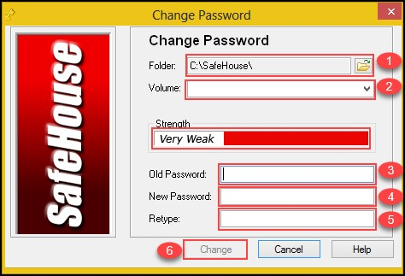

*Figure 18: Change Password Window*

When **Change Password** window opens, follow below steps:

1. Locate SafeHouse Explorer folder containing volume files.
2. Choose SafeHouse volume file.
3. Enter the old password.
4. Enter the new password.
5. Retype the new password.
6. Click **Change**.

### Making Self-extracting volume

The feature **Make Self-Extracting Volume** provides **t**hefacility to turn standard volume into self-running volume. For accessing files, the self-extracting volume does not require SafeHouse Explorer. It needs only the volume password.

**The following are the benefits of self-extracting volume:**

* Allows the user to access private files without any help of software, including SafeHouse Explorer
* Allows the user to share sensitive files with others who may not have Safehouse Explorer.
* Allows the user to distribute volumes by email quickly.

To **Make Self-Extracting Volume** >Click **Tools** on the menu bar **>** Click **Make Self-Extracting Volume** **>** SafeHouse window opens.

Self-extracting volumes can easily be attached to emails. The only thing you need to be careful about is that since these files are **.exe** files, many email readers (including Outlook) will block them. The simple cure is to put the volume inside a zip file because nearly all email readers allow zip files to pass through without alteration.

***Important:*** Never include the password in the same email as the secure attachment!

7777A popular application of SafeHouse's self-extracting volumes is to use them for making secure DVDs. Your files can then be accessed directly from the DVD without needing any other software, not SafeHouse Explorer!

Self-extracting volumes are created from within the regular version of SafeHouse Explorer using the Make Self-Extracting Volume item on the Tools menu. The tool works by making a copy of SafeHouse Explorer and then attaching a copy of one of your existing volumes.

The initial password for self-extracting volumes is the same as the original volume from which it was copied from. You can later change the password as often as desired just by opening up the volume.

The maximum size for self-extracting volume is 3GB.

# Frequently asked questions

1. Can securely deleted files recover?

No, once file is securely deleted, data in it removed forever.

# Troubleshooting

How do I recover a damaged volume?

The best way to recover when you sense your SafeHouse volume has been damaged is to restore from your most-recent safety backup. If you don't have a recent backup, there still might be hope due to the fact that SafeHouse is frequently able to keep a shadow copy of

certain critical information, and you can restore from that shadow in an emergency. For more information, see *How to Repair a Volume for more information*